Project Overview
Client: Private Homeowner
Location: Please choose a building parcel in Footscray – it does not have to be an empty parcel. Use VicPlan to conduct the search and retrieve relevant site information for the site analysis.
Project Type: New Residential Build
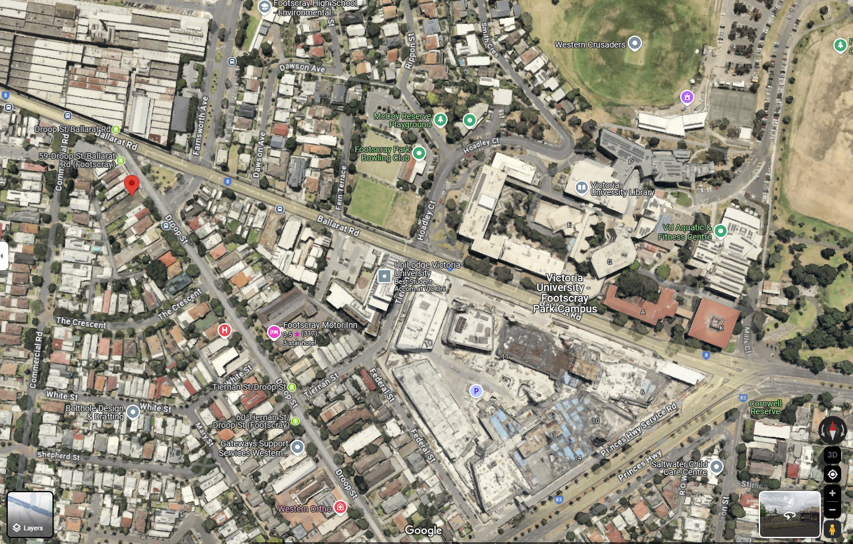

Design Objective
To create a one-level or two-level family home that accommodates a family of four, providing comfort, privacy, and flexibility while incorporating sustainable design principles. We recommend working on two levels if you work in a group of two. You can change this part of the brief according to the group size. For instance, a group of three people can work on a three-level house for a family of five or six.

Family Profile
- Parents: Working professionals who often work from home.
- Children: Two children, ages 8 and 12, requiring space for play and study.
- Pets: One dog, needing outdoor space.

Program Requirements
- Living Areas:
- Spacious open-plan living and dining area with direct access to the kitchen.
- Separate family room for entertainment and relaxation.
- Outdoor living space for dining and recreation.
- Kitchen:
- Modern kitchen with energy-efficient appliances.
- Island bench for additional workspace and casual meals.
- Walk-in pantry for storage.
- Bedrooms:
- Master bedroom with ensuite bathroom and walk-in closet.
- Two additional bedrooms for the children, each capable of accommodating a study area.
- Guest bedroom or a flexible space that can serve as a home office or guest room.
- Bathrooms:
- Family bathroom with a bathtub and separate shower.
- An additional powder room on the ground floor for guests.
- Ensuite bathroom for the master bedroom.
- Study/Home Office:
- A dedicated home office space that can accommodate two working adults, with built-in storage and ample natural light.
- Laundry Room:
- Functional laundry room with external access.
- Storage:
- Ample storage solutions throughout the house including linen closets, basement or attic space, and garage storage.
- Garage:
- At least a one-car garage with internal access to the house.
- Outdoor Area:
- Secure backyard suitable for children and pets.
- Landscaping that includes a vegetable garden and play area.
- Sustainable features such as rainwater tanks and solar panels.
Aesthetics and Style
- Be creative with the architectural language you use in the project.
- Use of sustainable and low-maintenance materials.
- Consider both functionality and aesthetics.
Sustainability Features
- Solar panels for renewable energy.
- Consider a rainwater harvesting system for garden and toilet flushing – be creative with different solutions.
- High-performance insulation and glazing to enhance thermal comfort and energy efficiency.
Compliance
- Ensure the design meets all local council regulations and building codes and considers the community’s architectural character (this comes from the site analysis).

